Alice480 Web Application

Design Requirements

©2013 Mercer University

Revisions

| Version | Primary Author(s) | Description of Version | Date Completed |
| --- | --- | --- | --- |
| 1.0 | Paul Mould | Information about the revision. | 12/13/13 |

Contents

Revisions i

1 Introduction 1

1.1 Purpose 1

1.2 Scope 1

1.3 Definitions, Acronyms, and Abbreviations 1

2 Architecture 3

2.1 Database Schema 3

2.1.1 Tables Design of Database 3

2.1.2 Simplified Relationship of Tables 6

2.2 Complex Relationship of Tables 7

3 Class Diagrams 8

3.1 Class Diagram: Holding a Contest. 8

4 Interface 9

4.1 Database Interface 9

4.2 Middle-Tier Interface 9

4.3 Web Interface 9

5 Algorithm Design 10

5.1 Contest Creation Process 10

5.2 Register Creation 11

# Introduction

## Purpose

This document describes the design of the Alice480 Web Application

## Scope

This design is for Alice48- Release 1.0, which is a system designed to host multiple programming contests.

## Definitions, Acronyms, and Abbreviations

See Table 1.

Table 1 Definitions, Acronyms, and Abbreviations

|  |  |
| --- | --- |
| User | a generic user/everyone. A basic user has the lowest set of permissions, the are only allowed to enter and compete in a contest. |
| Sponsor | someone who heads a team of users, can be teacher, dean, etc. must be affiliated with an institution or organization |
| Contest Organizer | Someone who has the permission to create a contest. They have the ability to set how many members per team. And who is able to join the contest, which is enforced by limiting who receives sponsor codes. |
| Sponsor codes | A sponsor code is a code of N alphanumeric characters that is associated with a particular contest. The code is used to sign up for a contest. A member will enter the code in the contest registration page to register for the contest. |
| Active Contest | All contests being run.  Everyone’s front page |
| Entered Contests | All contests in which a contestant are a part of.  Everyone/contestant |
| Created Contests | Contests create by a specified owner.  Sponsor/owner |
| Contests Management | Contests management by a user.  Sponsor/managers/Owner |
| Completed Contest | Ended contests. Everyone maybe be more detailed for participant. |
| Alice480 | The short form of the Alice 480 web application, Alice Programming Contest Site. |
|  |  |
|  |  |
|  |  |

# Architecture

## Database Schema

### Tables Design of Database

2.1.1.1 User Definition Tables

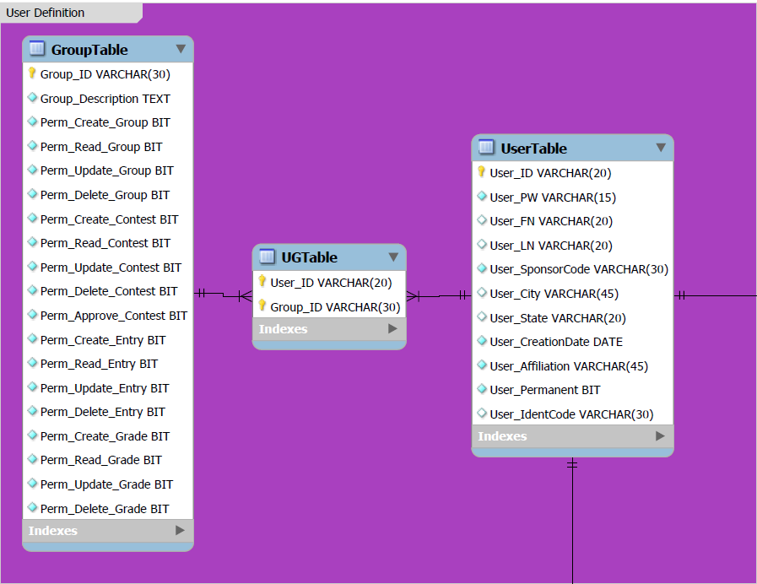

2.1.1.2 Solution Definition Tables

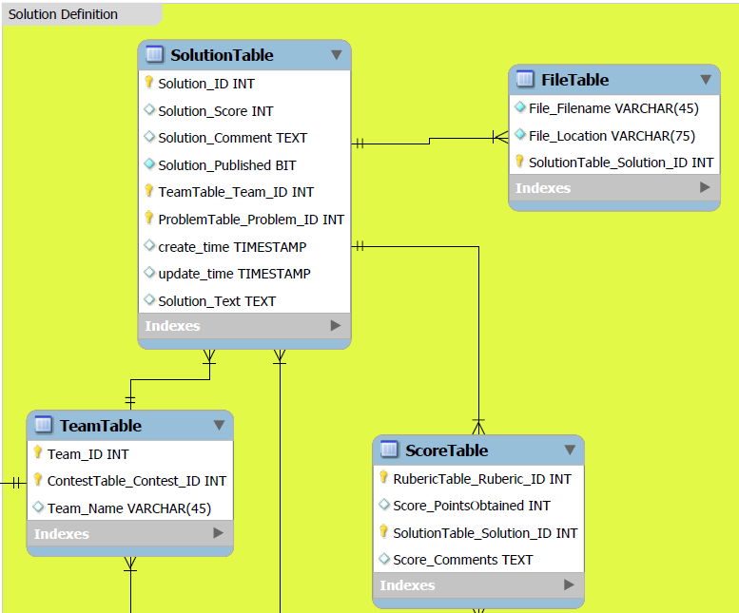

2.1.1.2 Contest Definition Tables

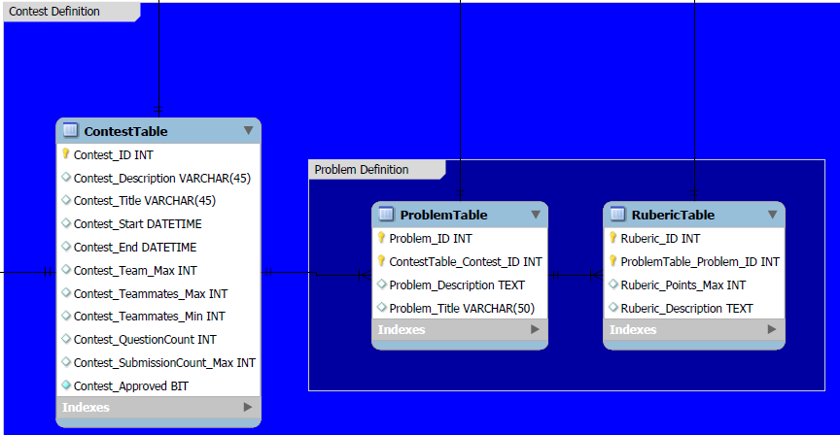

### Simplified Relationship of Tables

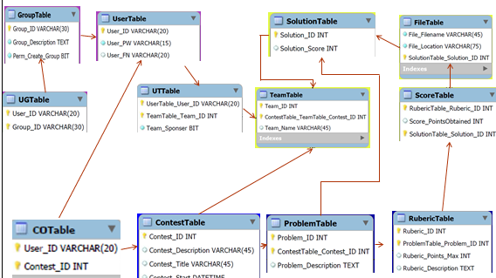

## Complex Relationship of Tables

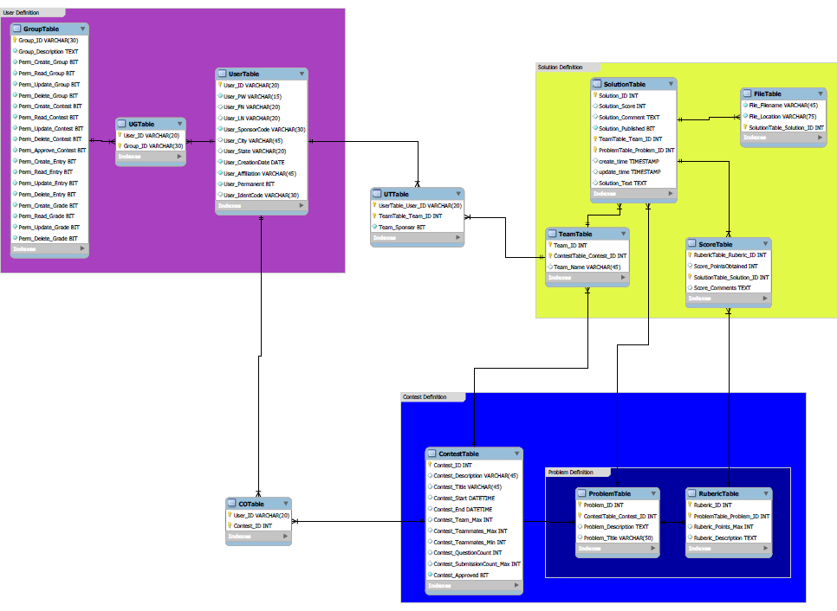

CONTEST DEFINITION

SOLUTION DEFINITION

USER DEFINTION

# Class Diagrams

## Class Diagram: Holding a Contest.

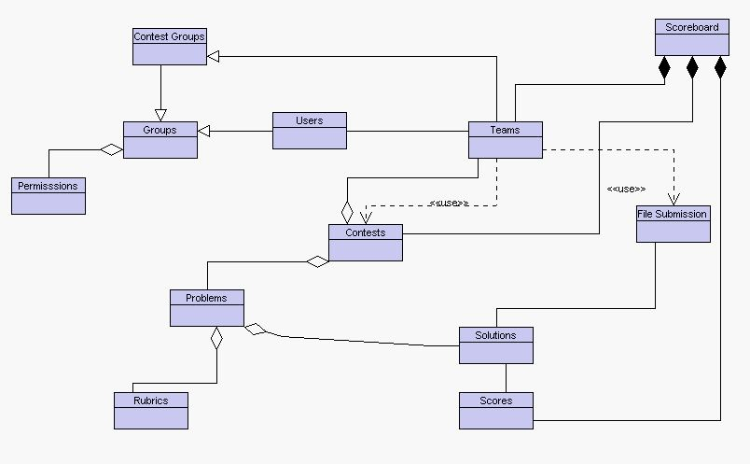

# Interface

## Database Interface

Our back-end uses a command line interface to create a database in MSQL.

## Middle-Tier Interface

Our middle tier interface for accessing the database is phpMyAdmin.

PhpMyAdmin is used to manage our database and connect it to our web-based front-end

## Web Interface

The front-end of our web application was built using the bootstrap web interface. Bootstrap is a sleek, intuitive, and powerful front-end framework for faster and easier web development

# Algorithm Design

## Contest Creation Process

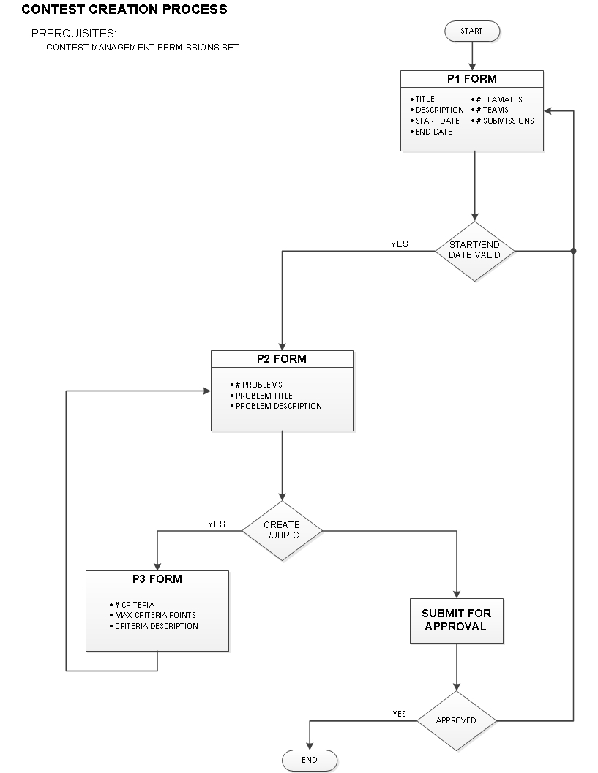

## Register Creation

